_{Where is Your Body?}
Description : Children with some disabilities, such as ASD, may suffer body dysregulation in certain areas. Part of the sense of body of dysregulation is not being able to feel where parts of the body are in space or how they are connected as a whole. This activity functions like the children’s game Simon Says and is also good for younger children who regularly have trouble with overly touching or grabbing things.
Develops : regulation of extremities and sense of body as whole.

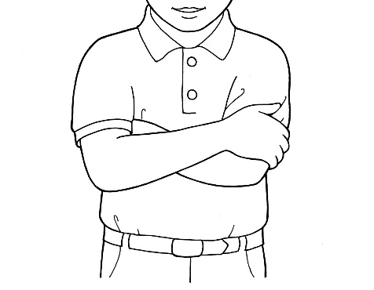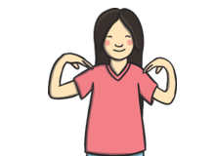
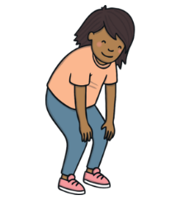

Instructions :
- When doing this exercise initially it is good to do it along with your child.
- Start by saying “where are your hands?” and hold out your hands.
- Once your child holds out their hands, say “now shake your hands” and both you and your child should move your hands in place in the air.
- Then say, “touch your arm” and touch your arms with your hands like in the picture.
- Continue identifying major body areas down the body (ex. “touch your shoulder”, “touch your head”, “touch your legs”, “touch your feet”, etc.).
- After you identified once the areas from the head to the feet, pick at random different parts to identify (ex. “touch your feet, touch your head, touch your knees” etc.) for a few minutes to complete the activity. You can also try changing the speed and calling out what areas to touch faster.
- After doing this activity, anytime during the day that your child is overly touching certain things that they are not supposed to touch or is acting dysregulated, you can address it by saying “where are your hands?” or have them touch the area that is dysregulated.

