_{Tin Can Tower (Fine Motor)}
Description : Children with a number of different special needs often have difficulty with what are called Fine Motor Skills. Fine Motor Skills are precise movements that can be done with the hands and wrist, such as handwriting, holding a pencil or brush, putting different small pieces together to build something and taking them apart, etc. This activity is very simple and can be made more complex and helps build a number of fine motor areas and fine motor control.
Develops : Fine Motor Skills (grasping, hand-eye coordination, stacking)
The Wall
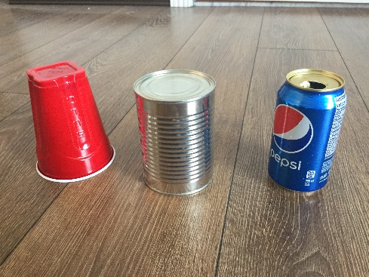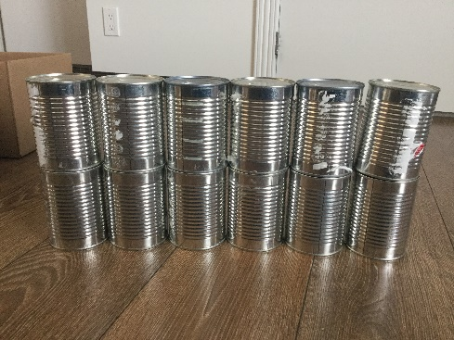
The Tower The Mountain
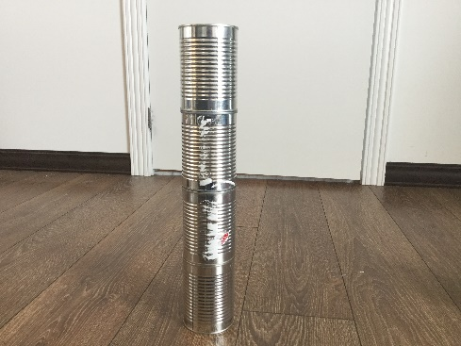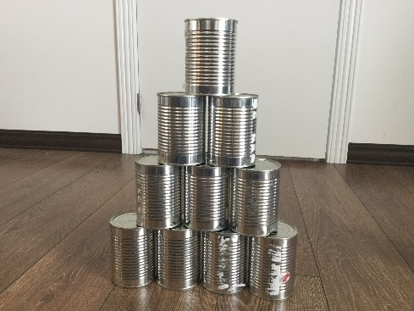

The Castle The Two Towers
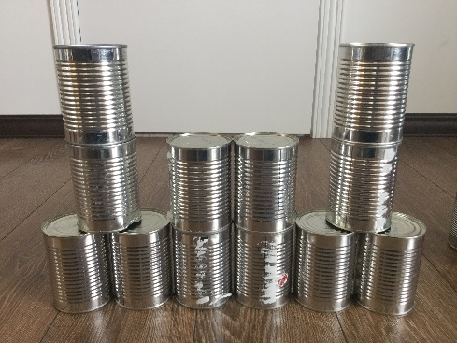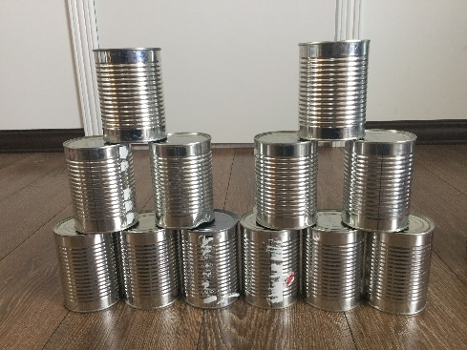

Instructions :
- To start you will need around 12 of the same item to stack. Empty soup cans work well but you can also use empty pop cans or cups.
- Begin with The Wall and have your child first line up 6 cans and then stack 6 on top.
- After your child can successfully make The Wall on their own have them do The Tower by stacking 4 cans on top of each other.
- Continue with The Castle and The Two Towers after this. With both make sure your child starts with the bottom row first before beginning to stack the rest of the cans.

This activity will take varying amounts of time depending on your child’s fine motor ability and can be repeated as needed.

