Everyday Stretches (Gross Motor)
Description : A number of children with different exceptionalities have difficulty with what are called Gross Motor Skills. Gross motor skills are abilities that allow people to do things that involve using the large muscles in the torso, arms, and legs to complete whole-body movements. This activity has multiple different smaller activities to help children develop torso strength, balance, and coordination.

Develops : Torso strength, balance, coordination, and different large muscle groups.
The Butterfly
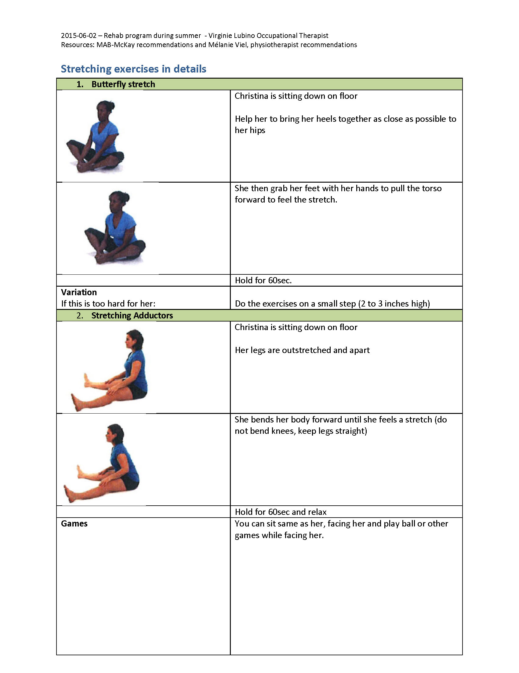
Back Stretch
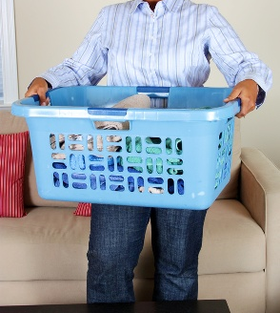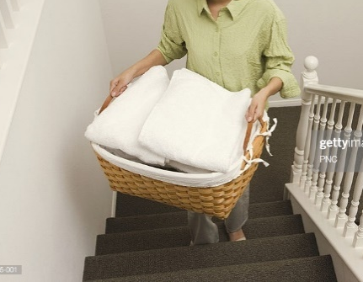
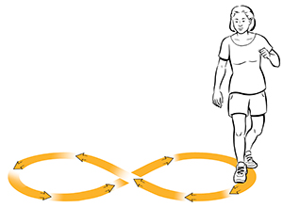

Instructions :
- To warm up your child’s muscles before the activity have them begin with the Butterfly and Back Stretch.
- For the Butterfly, have your child sit on the floor and tuck in their feet like in the picture.
- Then have your child grasp their feet with their hands, push down on their knees with their elbows, and lean forward as much as is comfortable. Hold this position for 1 minute.
- For the Back Stretch, have your child sit on the floor with their legs out like in the picture. Make sure their knees are not bent.
- Have your child reach forward to touch their legs as far as possible without it being uncomfortable or painful. Once again make sure they keep their knees straight. Have them hold the position for 1 minute.
- After stretches have your child lift a laundry basket 10 times. Fill the basket only enough so that your child can lift it without great difficulty.
- The actions for this movement are as follows: Your child bends down to pick up the basket off the floor, lifts the basket to chest height, turns with their hips, and puts the basket on something chest or elbow height (chair, table, etc.), and then reverses the series of actions to put the basket back on the floor.
- Following this have your child walk up and down a flight of stairs holding the basket. Repeat a few times depending on the distance of the stairs.
- After this activity is done, have your child walk in figure eights, like in the picture, around two objects like chairs or small furniture. Have them repeat this movement 3– 4 times.

