_{Applying Pressure}
Description : Children with some disabilities, such as ASD, may suffer body dysregulation in certain areas. During periods of dysregulation children might feel uncomfortable and even a painful sensation. One of the ways to relieve this dysregulation is apply pressure to different areas.
Develops : regulation of extremities and sense of body as whole.

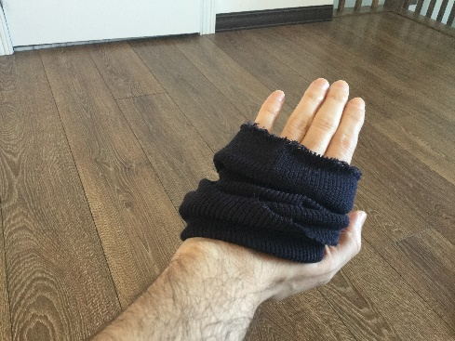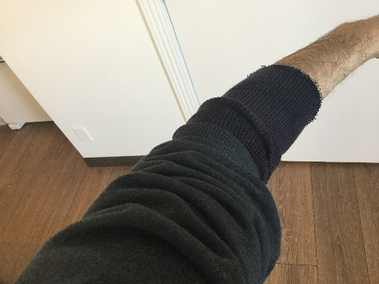

Instructions :
- When your child is dysregulated they will often become upset. For some children, this dysregulation is in specific areas such as their feet or neck.
- Start by either lightly massaging or lightly applying pressure with your hands to the extremities (hands, feet, neck).
- Slowly move your hands and apply pressure up and down the limbs from the hands to the forearm or feet to knee or along the base of the neck.
- Once your child has begun to calm a little or you have identified the area where the dysregulation is occurring, you can have them wear a cut up sock or knitted cuff (and soft cloth elastic or Velcro will also work) on the area. This will provide a continuing sense of pressure in the area.
- As your child gets more used to this support, they will be able to position the sock or knitted cuff on their own.

