SOCIAL-EMOTIONAL
HEALTH
BE THE POND

A short mindfulness video for kids. In this episode of Cosmic Kids Zen Den I explain in a kid-friendly way that we are separate from our feelings. They come and go - and we can observe them - without getting swept up by them. There's a really clever way of remembering this - our mind is like a pond full of fish. The fish are our feelings. If we remember to Be The Pond, we'll let those feelings just swim by. Be the Pond!

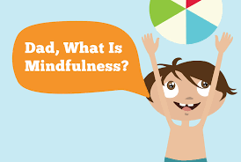

Paste and click on https://www.youtube.com/watch?v=wf5K3pP2IUQ

