_{Writing Basics}
Description : One are of the areas where children with Fine Motor and other difficulties struggle is handwriting. Even for older children who are capable of writing, specific learning difficulties may become evident when examining their handwriting. As handwriting is a complex task that requires a number of Fine Motor skills, this exercise will strengthen some necessary basics to begin writing but will still be useful practice for older children who might be fluent in written English but have difficulty with handwriting.
Develops : Fine Motor Skills related to handwriting (grasping, hand-eye coordination, manipulation of a writing tool)

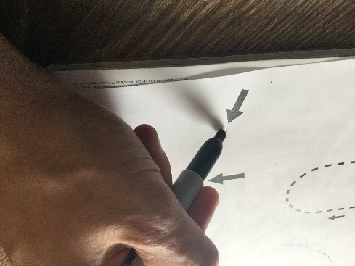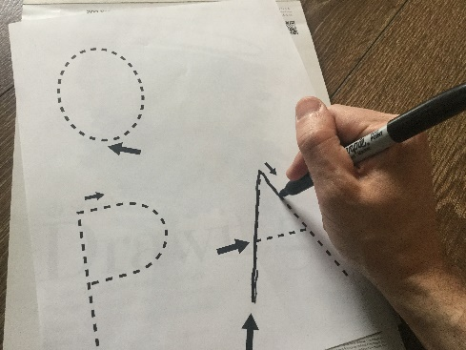
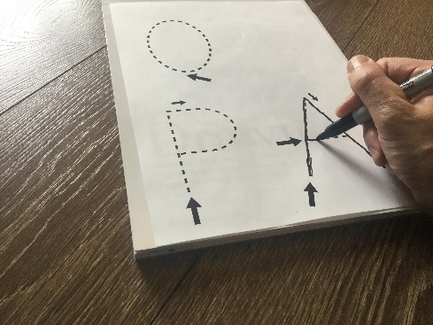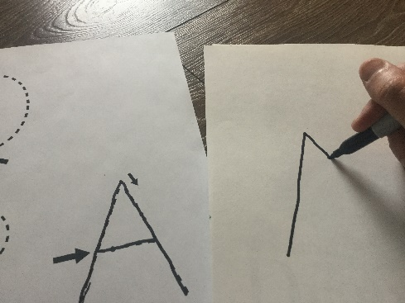

Instructions :
- For this exercise you can either print out exercise sheets below or can do them on a blank piece of paper. Depending on your child’s ability with writing and ability to hold writing tools (ex. pencil, pen, or markers) your child can use either a pencil (if they used to writing), markers (if your child has some difficulty with writing or tracing lines), or a paint brush (if your child has high levels of difficulty with Fine Motor tasks).
- Begin with the lines in the first exercise and progress through until your child completes the letters in the third exercise. If you do not have access to a printer you can draw or write each item on a blank piece of paper and have your child copy it either on a separate sheet of paper or next to your example.
- When forming each item in the exercise, start at the arrow and follow the dotted line, without lifting your hand before coming to the end of the dotted line. For more complex items, there will be smaller arrows to guide you in what direction to follow.
- For items with two large arrows, start with the one closer to the bottom of the page and follow the dotted line to the end before lifting your hand to start the next line indicated by second large arrow.

