_{Cat’s Cradle}
Description : In the development of Fine Motor skills, timing, fluidity, and repletion of movements are indicative of higher levels of Fine Motor capabilities. Cat’s Cradle (the name in English for a traditional game) is a fun game that you can play with your child once they become more comfortable with some Fine Motor skills such as grasping, pulling, threading, and hand-eye coordination and will help to develop better fluidity and timing for these skills.
Develops : Develops fluidity and timing for several Fine Motor Skills.

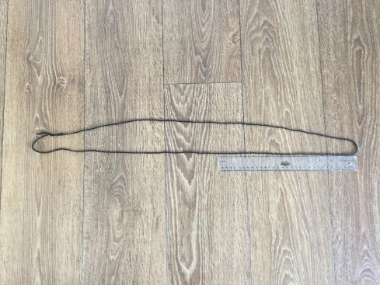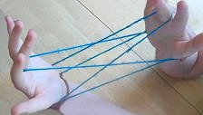

Instructions :
- For this activity you will need approximately 4-5 feet (around 1.5 metres) of yarn or string.
- Tie the yarn at the end so it makes a loop.
- Watch the video found here for a demonstration of how to play Cat’s Cradle (https://www.youtube.com/watch?v=VpHTPnrYLzQ). If you do not have regular access to the internet the instructions can also be found at http://www.momsminivan.com/how-to-do-cats-cradle.html.
- As your child becomes more familiar with the movements and becomes more fluid, increase the speed of your movement. Once your child can match your speed and maintain it for one round, continue to increase your speed a little be more for the next round until your child can again match your speed.
- Continue repeating the movements until a mistake is made, at which point start again slowly from the first Cat’s Cradle shape (in the picture above).

