_{Threading (Fine Motor)}
Description : Children with a number of different special needs often have difficulty with what are called Fine Motor Skills. Fine Motor Skills are precise movements that can be done with the hands and wrist, such as handwriting, holding a pencil or brush, putting different small pieces together to build something and taking them apart, etc. This activity is very simple and can be made more complex and helps build a number of fine motor areas and fine motor control.
Develops : Fine Motor Skills (threading, hand-eye coordination, pulling, grasping)

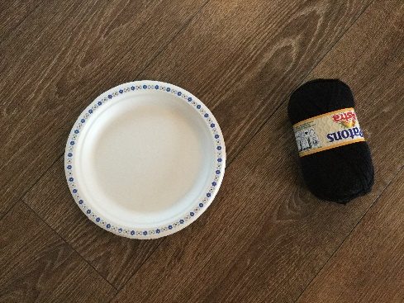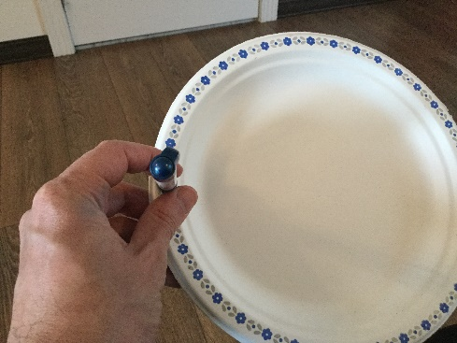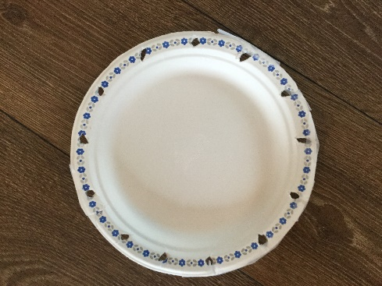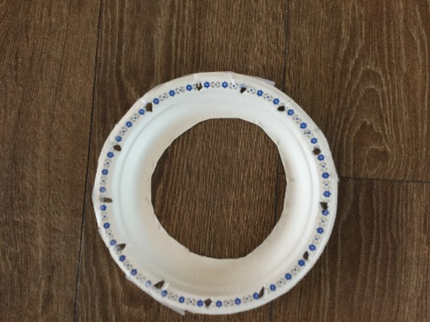
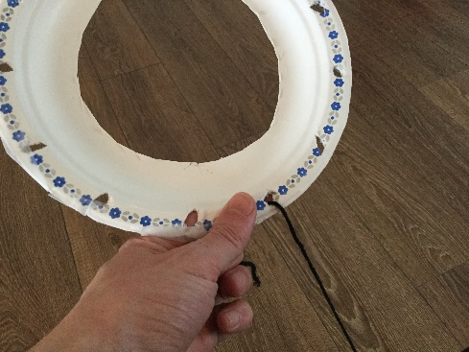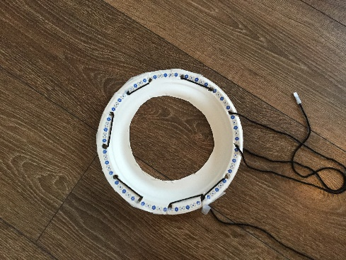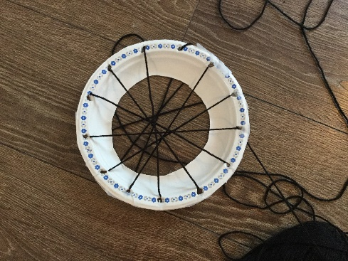

Instructions :
- For this activity you will need a paper plate, yarn or very thin rope, and scissors.
- Start by punching holes, at equal distance apart, around the plate. You can use a pen or scissors. Make sure that the holes are a fair bit larger than the yarn so it is easy to get the yarn through. After you are done you can but tape around the edge of the plate to reinforce it and prevent the holes from ripping.
- After the holes have been punched in the plate cut out the center of the plate. This will make it easier to hold and will allow your child to better see what they are doing when they are threading the yarn.
- Once everything is cut out, have your child start threading the yarn through the holes around the plate. You can tape the tip of the yarn to make it easier for them to get it through the holes. NOTE: If your child is having difficulty with this step you can do it for them and have them do Step 5 until they have developed more skill and can thread the plate on their own.
- Once all the holes have been threaded, have your child remove the yarn by pulling it back through holes in reverse order.
- Once your child has mastered threading around the plate, you can have them begin to thread across the plate through the opposite holes. Have the child turn the plate clockwise as they thread so that they are always threading through the top (12 O’clock) and bottom (6 O’clock) holes.
- Once your child is finished threading across the plate, have them remove the yarn by pulling it the reverse out of the hole. Like in Step 5.

This activity will take varying amounts of time depending on your child’s fine motor ability and can be repeated as needed.

