_{Indoor skating}
Description : This fun activity helps can be done alone or with another family member.
Develops : Vestibular system (recognizing speed and direction)

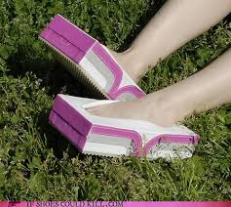
Materials :
- Empty tissue boxes (or larger depending on size of feet)
- Blanket
- Optional : items to decorate ‘skates’

Instructions :
- Place one foot in each empty tissue box.
- Child holds one end of the blanket, adult the other. The adult then leads the child around. The aim is to keep the blanket taut – not to just pull the child. The child will have to adjust the speed with which they move their feet and direction they turn them in order to keep going.

- Variations :
  - try going from carpet to smooth surface
  - have the child yell directions
  - set up an ‘obstacle course’ that the child has to skate around
  - Have fun with the decorating – dinosaur feet? Robot feet? So many possibilities!

